|  |  |  |
| --- | --- | --- |
| **Indicator** | **What is a positive sign?** | **Sector or All companies** |
| **P/E Ratio** | **Lower, less money necessary to make 1$ profit-**  **High could indicate expected earnings, low could mean the company is undervalued** | **Sector** |
| **P/S Ratio** | **A low ratio may indicate possible undervaluation, while a ratio that is significantly above the average may suggest overvaluation.** | **Sector** |
| **P/B Ratio** | **I’m a bit confused** | **Idk fam** |
| **Price-To-Cash-Flow Ratio** | **High ratio could indicate investors valuing it high because of its growth prospects.**  **Stable companies, but companies that might have low prospects of growth, have lower valuation trades** |  |
| **Enterprise Value to EBITDA** | **Typically below 10** | **Sector** |
| **Enterprise Value to Sales** | **High- sign that investors think sales will greatly increase**  **Low- sign that future sales prospects aren’t great**  **Usually between 1-3** | **Sector** |
| **Earnings per share** | **I mean, I think higher is better** | **Sector probably, but main is also probably okay** |
| **Revenue/Employee** | **Higher is better, more revenue** | **Compare to sector** |
| **Receivables Turnover Ratio** | **Too sketchy, wouldn’t trust** |  |
| **Asset Turnover Ratio** | **Higher ratio = better performance, more revenue per assets** | **Sector, definitely** |
| **Gross Margin** | **I guess higher is better idk** |  |
| **Operating Margin** | **High is better, increasing is earning more per dollar of sales** |  |
| **Net Profit Margin** | **Indicates profitability and increases and decreases in net profit margin can indicate whether or not a company’s actions are successful** |  |
| **Return on invested capital** | **“If ROIC is greater than the weighted average cost of capital (WACC), the most common cost of capital metric, value is being created. If it is not, value is being destroyed. For this reason ROIC is one of the most important valuation metrics to calculate.”** |  |
| **Weighted Average Cost of Capital** | Formula for Weighted Average Cost Of Capital (WACC)  Re = cost of equity Rd = [cost of debt](https://www.investopedia.com/terms/c/costofdebt.asp) E = market value of the firm's equity D = market value of the firm's debt V = E + D = total market value of the firm’s financing (equity and debt) E/V = percentage of financing that is equity D/V = percentage of financing that is debt Tc = corporate tax rate |  |
| **Debt/Equity Ratio** = Total Liabilities / Shareholders' Equity | Higher is not great, too much debt for not enough equity  Lower is relatively low debt, much less risk | **Sector/industry** |
| **debt-to-capital** | The higher it is, the riskier- low is safer | **Sector probably** |
| **Total Debt To Total Assets** | Ratio over 1 means more liabilities than assets, high ratio means company may risk defaulting on loans if interest rates rise  Below 1 means a greater portion of assets are funded by equity | **Assess trends in ratio** |
| **Interest Coverage Ratio** | Lower ratio = more burden of debt on company, 1.5 or lower is questionable, below 1 means it is not making enough money to satisfy interest expenses, 2.5 is a warning sign | **Who knows** |
|  |  |  |
|  |  |  |
|  |  |  |

**Valuation:**

* **P/E Ratio - Market Value per Share / Earnings per Share**
  + Essentially is the amount that is necessary to invest in a company in order to earn one dollar of profit
  + I.e. if the P/E ratio is 20, you must purchase 20$ of stocks to make a dollar profit in a year
* **P/S Ratio** - Dividing market capitalization by a company by total sales over a 12 month period
* **P/B Ratio** = Market Price per Share / Book Value per Share
  + Book Value per Share = (Total Assets - Total Liabilities) / Number of shares outstanding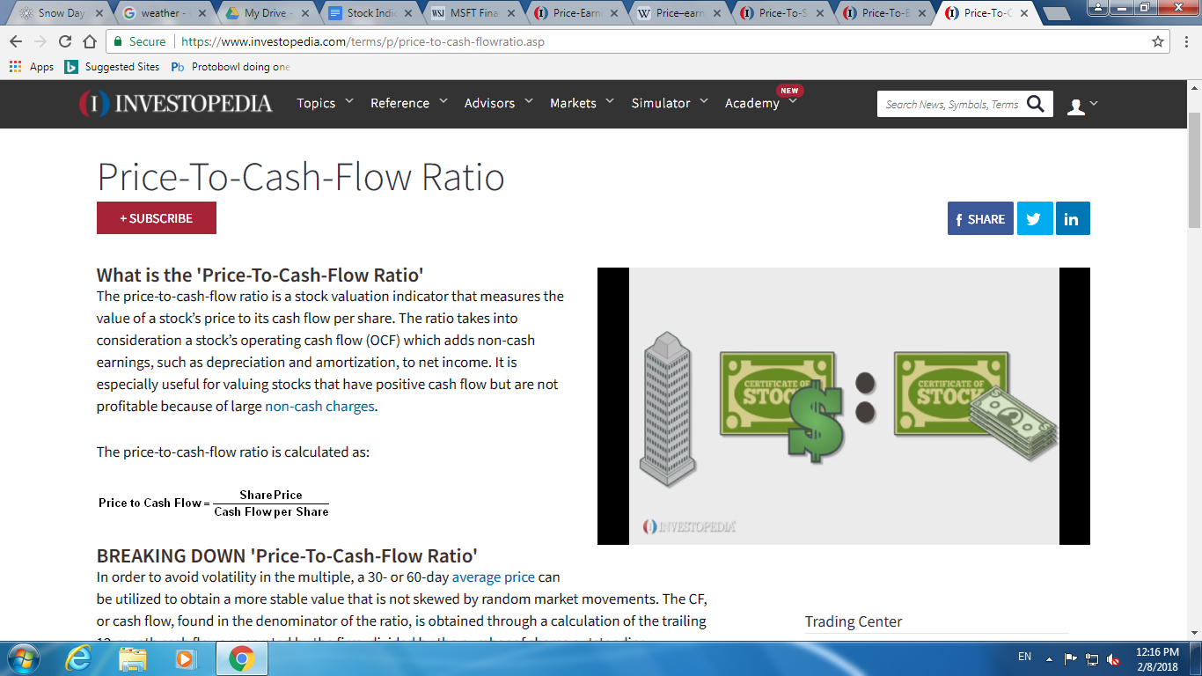
* **Price-To-Cash-Flow Ratio** 
  + The price-to-cash-flow ratio measures how much cash a company generates relative to its stock price, rather than what it records in earnings relative to stock price as measured by the price-earnings ratio.
* **Enterprise Value to EBITDA**
  + This popular metric is widely used as a valuation tool, allowing investors to compare the value of a company, debt included, to the company’s cash earnings less noncash expenses. It is ideal for analysts and potential investors looking to compare companies within the same industry.
  + Though the price-to-earnings, or P/E, ratio is often primarily used as a valuation tool, there are benefits to using it along with the EV/EBITDA, or to using the latter on its own. The EV/EBITDA is considered by some to be a better valuation metric because it remains unaffected by changing capital structures and offers fairer comparisons of companies with capital structures that differ. It also removes the effects of noncash expenses on a company’s value.
  + Below 10 is good
* **Enterprise Value to Sales**
  + Enterprise-value-to-sales is a valuation measure that compares the enterprise value (EV) of a company to the company's sales. EV-to-sales gives investors a quantifiable metric of how much it costs to purchase the company's sales.
* Total debt to enterprise value
* Total debt to sales
* **Earnings per share**, how much a stock profits. EPS = (Net Income - Dividends on Preferred Stock) / Average Outstanding Shares
* Outstanding Shares
  + Diluted EPS entails a complex calculation that determines how many shares would be outstanding if all exercisable warrants, options, etc. were converted into shares at a point in time, generally the end of a quarter. Diluted EPS is preferred, because it is a more conservative number that calculates EPS, as if all possible shares were issued and outstanding.

**Revenue/Employee**

* Pretty simple, highest is better because higher productivity
* Income per employee
* **Receivables Turnover Ratio**
* **Formula for Receivables Turnover Ratio** calculated as net credit sales/by average accounts receivable
  + A low ratio, in a similar way, can also suggest a few things about a company, such as that the company may have poor collecting processes, a bad credit policy or none at all, or bad customers or customers with financial difficulty. Theoretically, a low ratio can also often mean that the company has a high amount of cash receivables for collection from its various debtors, should it improve its collection processes. Generally, however, a low ratio implies that the company should reassess its credit policies in order to ensure the timely collection of imparted credit that is not earning interest for the firm.
* **Asset Turnover Ratio**
  + Asset turnover ratio is typically calculated over an annual basis using either the fiscal or calendar year. The total assets number used in the denominator can be calculated by taking the average of assets held by a company at the beginning of the year and at the year’s end.
  + Generally speaking, the higher the asset turnover ratio, the better the company is performing, since higher ratios imply that the company is generating more revenue per dollar of assets.
  + Compare against other companies in same sector

**Liquidity**

* Current ratio divides total current assets by total current liabilities, basic analysis regarding the coverage level of current debts by current assets
* Quick ratio only cash, marketable securities, and accounts receivable in numerator, reflects potential difficulty in selling inventory or prepaid assets in an emergency
* Cash and cash equivalents by current liabilities

**Profitability**

* Gross Margin The total sales revenue minus the cost of goods, divided by the total sales revenue. That number is then expressed as a percentage.
* Operating Margin Similar, except subtracts more costs, the operating income/net sales
* Percent profit per dollar
* Company earning before tax as a percentage of total sales before tax, pretax margin
* Net Margin (Total revenue - total expenses)/total revenue
* Return on assets
* Net income/total assets
* Net Income/Shareholder's Equity
* Earnings before taxes and stuff/total capital **Total Capital** = Short-term Debt + Long-term Debt + Shareholders' Equity
* **ROIC** is most useful when you're using it to calculate the returns generated by the business operation itself, not the ephemeral results from one-time events. Gains/losses from foreign currency fluctuations and other one-time events contribute to the net income listed on the bottom line, but they're not really recurring results from business operations.ROIC = ( Net income - Dividends ) / ( Debt + Equity )
* **The D/E ratio** indicates how much debt a company is using to finance its assets relative to the value of shareholders’ equity. The formula for calculating D/E ratios is:
* **Debt/Equity Ratio** = Total Liabilities / Shareholders' Equity
* A high **debt/equity** ratio generally means that a company has been aggressive in financing its growth with debt. Aggressive leveraging practices are often associated with high levels of risk. This may result in volatile earnings as a result of the additional interest expense.
* The **debt-to-capital** ratio is calculated by taking the company's interest-bearing debt, including both short- and long-term liabilities and dividing it by the total capital.
* The **debt-to-capital ratio** gives analysts and investors a better idea of a company's financial structure and whether or not the company is a suitable investment. All else equal, the higher the debt-to-capital ratio, the riskier the company.
* Total Debt To Total Assets
* Creditors use the ratio to see how much debt the company already has and if the company has the ability to repay its debt, which will determine whether additional loans will be extended to the firm.
* 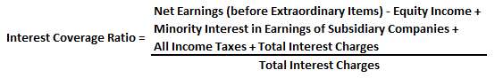
* Essentially, the interest coverage ratio measures how many times over a company could pay its current interest payment with its available earnings. In other words, it measures the margin of safety a company has for paying interest during a given period, which a company needs in order to survive future (and perhaps unforeseeable) any financial hardship that may arise. A company’s ability to meet its interest obligations is an aspect of a company’s solvency, and is thus a very important factor in the return for shareholders.